Developers Manual for the South African TIMES (SATIM) Energy Model

**Energy Research Centre**

**Systems Analysis & Planning Group**



***Working Draft***

Version 1.0

2013/03/12

Contents

The Basics 3

Terminology 3

Opening SATIM 3

To Run Model 4

Loading Alternative Scenarios 5

Constraints in the Alternative Scenario 6

Accounting for Emissions 7

Sets and Subsets 7

Working with Emissions Constraints 9

Automated Outputs Spreadsheet 10

# The Basics

## Terminology

BASE: This contains the structure and quantities of primary and secondary energy supply to the sectors

Reference Case: Each sector file has a reference scenario / case. This is for the whole modelling period time horizon. Generally this would be ‘business as usual’

## Opening SATIM

To open SATIM. Click File\Open Database. Select SATIM.mdb (access file)

If you create a new base case you need to upload the SUP and TIME_SLICE files

SUP file contains all fuels for all sectors

To upload one of the sector files etc (eg TCH_SUP) to the Base case:

Highglight ‘BASE’ in **Scenarios** window

Click File\Import\Model data from Excel

Click ‘Add’ on form below

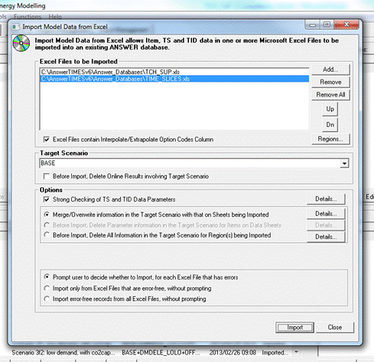

Files will appear in dialog window.

NB: ‘Options’ TAB – If numbers only have been updated then select Merge/Overwrite but if a new fuel for example has been added you need to select option ‘Before Import, Delete All Information in the Target Scenario for Region(s)….’

## To Run Model

Click on desired scenarios in Scenarios Window and use arrows to toggle across to ‘Selected Scenarios’

Double click to select scenario even though it appears in the window.

Click ‘Run Model’

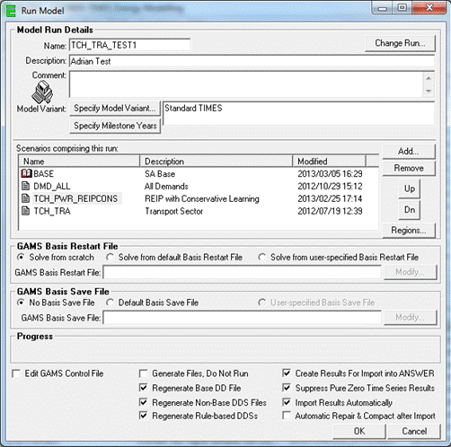

NB: Order Matters ie: Demands need to be on top

## Loading Alternative Scenarios

Go to the management Window

At the bottom of the Data Management\Scenarios window click ‘New’ and create a new scenario

Select the new scenario and Click File\Import\Model data from Excel

Select the spreadsheet with alternative data and import.

It is expedient in many instances to just import data for one parameter where this is the only difference from the reference scenario.

Alternative scenario may only involve a difference in say penetration rates with the reference scenario. In this case we would only want to import these values and not all the unchanged parameters.

Penetration rates, which in the case of the transport sector are sales shares are input in Sheet ‘TS_UCnTech,

Other sheets can be ‘commented out’ by blanking the value in Cell ‘A1’ which can have one of three possibile values

* ITEMS
* TS DATA – (Time Series Parameters)
* TID DATA – (Time Independent parameters)

A cell formula can be entered in cell A1 to respond to a flag on another sheet. In this way the imported data for the alternative scenario can be kept a minimum but with just toggling a flag on the master sheet for that sector.

### Constraints in the Alternative Scenario

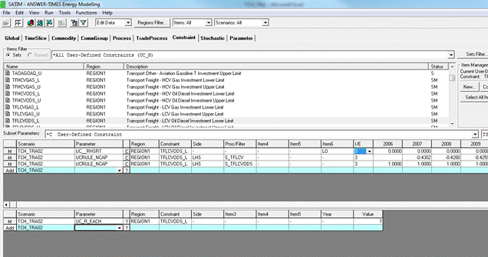

Constraints represent an equation or inequality of the following form:

Ai X Ct + Bi X Ck (=, <, >) Xt  where

A and B are coefficients

Ct , Ck is a variable representing a set, technology or commodity

Taking the 2nd User-Defined Constraint above as an example, this expresses the inequality

1 •NCAPdiesel LCV > 0.43• NCAPall LCV for the year 2007

Where:

* NCAP is the share of new capacity of a technology
* Diesel LCV is a technology which has the code ‘TFLCVODS’ above
* All LCV is a set of technologies, all the types of LCV, which has the code ‘S_TFLCV’ above

The parameter ‘Side’ set to LHS means that the terms of the inequality are shifted to the left hand side of the equation as follows:

1•NCAPdiesel LCV - 0.43 •NCAPall LCV > 0

This is why the coefficient 0.43 is entered as a negative in the coefficient column for the year 2007.

Note: Parameter ‘I/E’ set to 3 sets TIMES to interpolate and extrapolate between years but in this case a bug means it does not work and a complete data set needs to be entered.

# Accounting for Emissions

_S – emissions from combustion in SA

_R – emissions from outside borders

Only coal regional (CLR) and Gas Region (gas plants outside SA) [GAR] require definition of “_R” emissions. This will generally only be for the power sector unless we wanted to account for refinery, particularly CTL or GTL in the region, emissions for imported liquid fuels.

# Sets and Subsets

Caution needs to be exercised with the ANSWER-TIMES interface in particular when setting up sets and sub-sets of technologies. For example a set of SUV vehicles in the Transport Sector that includes all technologies like gasoline ICE, diesel ICE, gasoline hybrid and so on is useful for both constraints and outputs but we may want sub-sets of that set, for instance a subset of hydrogen fuel cell SUV vehicles for use in a constraint like a penetration rate. This has been applied in SATIM and thus adding a new technology begets a new subset. Clearly this subset needs to be part of the set of all SUVs but in ANSWER this cannot be accomplished by using the spreadsheets loaded into scenarios and must be done in the ANSWER interface itself or something like the following error will be thrown on loading the Transport Sector spreadsheet.

TS DATA REGION1 (TS UCnTech)

Record 195 has error: 'S_TPPRSUVHGNF' is not a valid Item Name for Region -

UCRULE_NCAP TPPRSUVHGNF_L LHS S_TPPRSUVHGNF - 3 1 1

In the above example the technology ‘TPPRSUVHGNF’ has been added to the spreadsheet but the subset ‘S_TPPRSUVHGNF’ has not been defined and added to the set ‘S_TPPRSUV’. This needs to be done in the ANSWER interface as follows.

Step 1: Select the BASE case in the ‘Selected Scenarios’ window

Step 2: Click the ‘Edit Data’ button and click the ‘Process’ tab

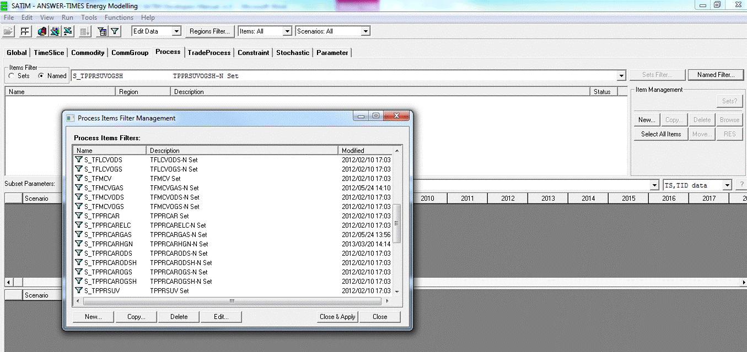

Step 3: Select the ‘Named’ Items filter and then click the ‘Named Filter’ button which will bring up the ‘Process Items Filter Management’ window as shown above.

Step 4: Either copy a similar existing set as shown below or create a new one.

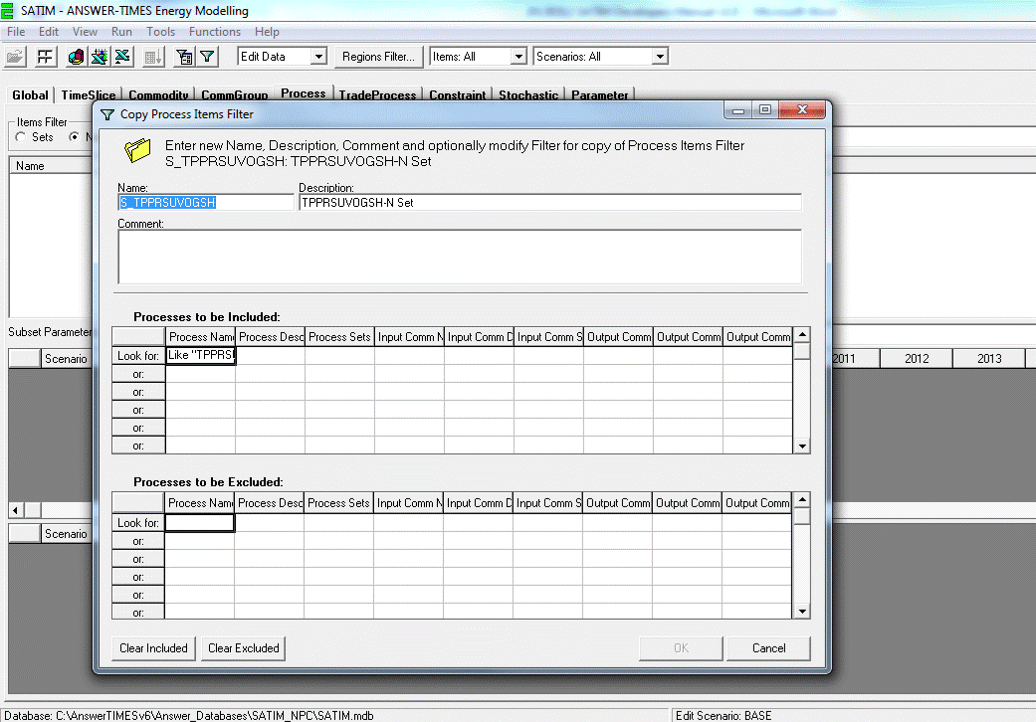

Step 5: Edit the set name and link it to the correct technology. A wildcard can be used as shown to include multiple technologies in the set.

Step 6: Click ‘Close & Apply’

Step 7: Check that the new set appears in the ‘Process Items Filter’ list and has the correct nomenclature.

# Working with Emissions Constraints

Emissions constraints can be adjusted and optimised by viewing the impact on model run results as follows:

To see margin on constraint

EQ.COMBAL_M = Margin on the constraint in million Rand per ton. Interpretation: If you had to increase the constraint by 1 unit (kton in the case of CO2) it would save the indicated margin.

To see margin on competing technologies:

# Reviewing Installed Capacity of Technologies in the Results

Select ‘Process’ Tab. Select technology and scroll down to commodity VAR_NCAP.M. This will be in the same units as the investment cost (R million / PJ.annum).

VAR_NCAP.L This is new capacity of the indicated technology. It appear iLED (lead time) years before the onset of VAR_CAP.L which is capacity installed that is ready for production

# Changing the Discount Rate

View data of BASE scenario. Click ‘Global’ tab. Click Region1. Adjust parameter G_DRATE.

# Set a Carbon Cap

Select CO2 commodity eg PWRCO2S. Adjust COM_BNDNET for each year of CAP

# Automated Outputs Spreadsheet

This spreadsheet queries the SATIM database and extracts the results for selected cases. This was developed internally and has its own conventions distinct from ANSWER-TIMES.

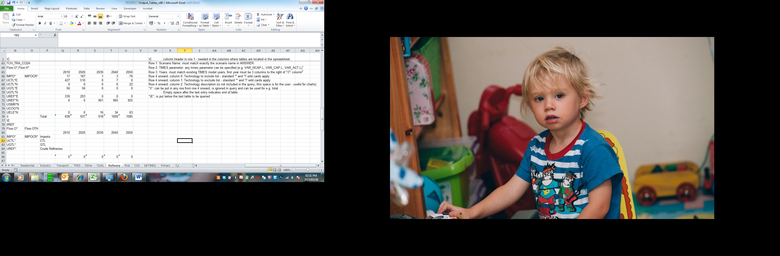

Notes:

1: Instead of VAR_FLO-IN.L or VAR_FLO-OUT.L, FlowI or Flow can be used instead, after FlowI or Flow, the commodities can be specified. Several can be specified by comma separating as per example above. Column 1 can be used to exclude Commodities in the same way. “*” and “?” wildcards can be used.

2: Blank column after the last year specifies the end of the table column-wise.

## Querying the Project Access Database from the Outputs Spreadsheet VBA Code

It may be necessary to customise the Outputs spreadsheet to more conveniently display results. In order to do this the developer needs to navigate both the Access Database where ANSWER-TIMES stores a project with all its data and scenarios as well as the VBA code in the Outputs spreadsheet.

In order to design the SQL queries required the developer will need to open the Access database to read the correct table and field names.